**CANTEEN MANAGEMENT SYSTEM**

**Objective:**

Canteen management system will able to provide fast services to their customers by using their records which has been saved previously. However new records can be added any time whenever any customers visited to their canteen shop. To identify the customers each customers will be provided with their customer id and during data entering process all their basic information’s will be added into the file in the binary format.

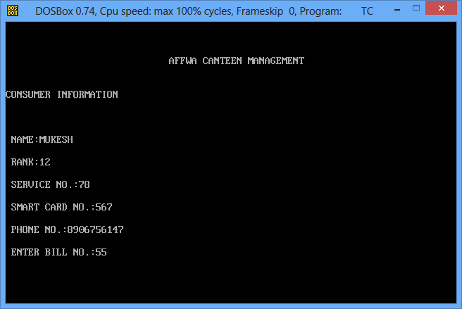

Each customer will be provided with smart card and each smart card will have a unique number by which system will easily able to identify their customers and prepare their bills for the services which they have taken. It will also help the canteen shop admin to identify such customers whose payment has not been cleared till date. Admin will have the facility what are the items which are available at their shop at particular time and what is the exact quantity of any particular item.

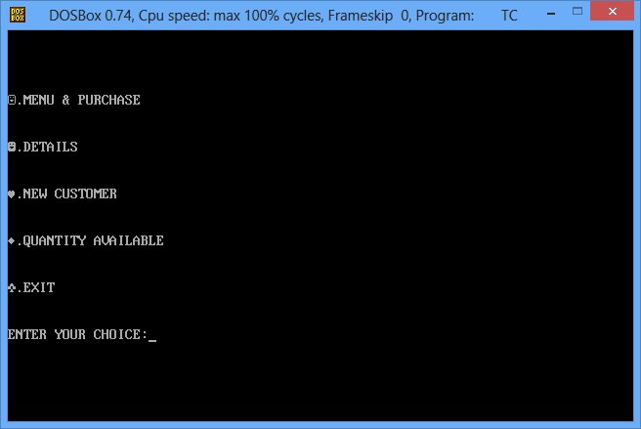

As customers will also able to check their account status, services which they have taken and bills which they paid and due amount details, if there is any for their account. Details section will also make their customers updated regarding business hours of the canteen.

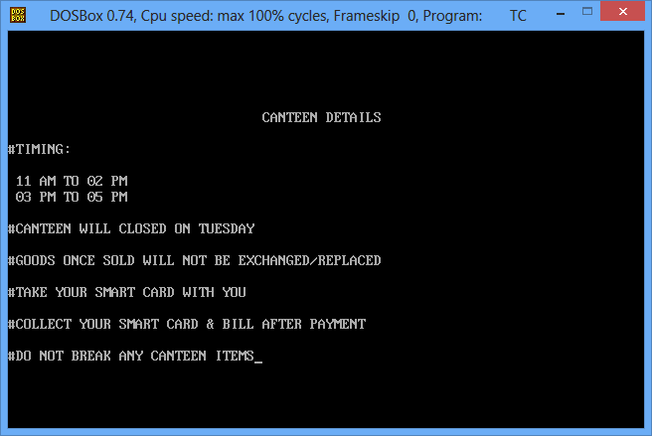

**Existing System:**

Existing system does not allow customers to know their payment details and about their due payment within the canteen. In this system admin does not have the facility to update or make changes to any information and also not having facility to add, modify or delete any services which are being provided within their canteen. As admin do not have the facility of knowing what quantity is available for particular product or services which are being available within their shop, they do not able to make quick action by which it can make their big loss for their daily business transactions.

**Proposed System:**

The current system will allow their users to know what items are available under their canteen shop and in what quantity they are available.

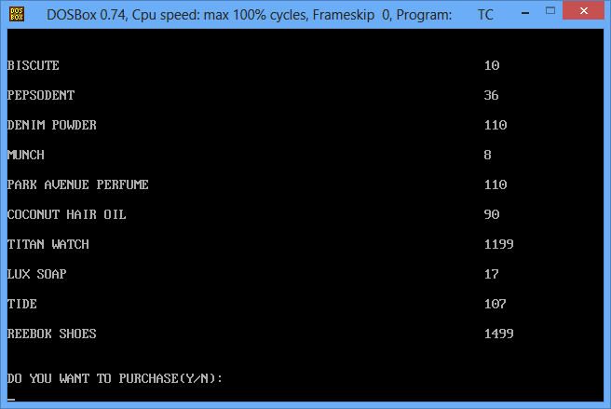

At the mean time customers are also provided with option of purchasing the particular item. If the customer enter the yes option, then they can enter the number of quantity for each product and at the end they will able to get the bills for the items which they have purchased and finally backup their purchased items from the pickup center. Thus admin will only having the responsibility to check the final bills and provide better services to their new and existing customers.

